**WRITE UP**

**Project:**

Movie Ticket Simulator

**Developer Details:**

Pradeepa S

Employee id – 2529352

**Algorithm:**

**Step 1:** Start the application

**Step 2:** First need to choose whether are you a user or admin

**Step 3:** If Admin means, you have four options as add user, Remove user, print

user and exit from application

**Step 4:** If User means, go to Login page.

**Step 5:**In login page, you login directly if you already have a account otherwise

register and then login

**Step 6**: Select the Movie details such as Movie name, show time and seats.

**Step 7:** After selecting all the details, proceed to payment.

**Step 8:** After confirmation from user, do payment. Ticket is booked once

payment is done successfully.

**Step 9:** Book another ticket if need otherwise quit from the application.

**Step 10:** End the program.

**Flowchart:**

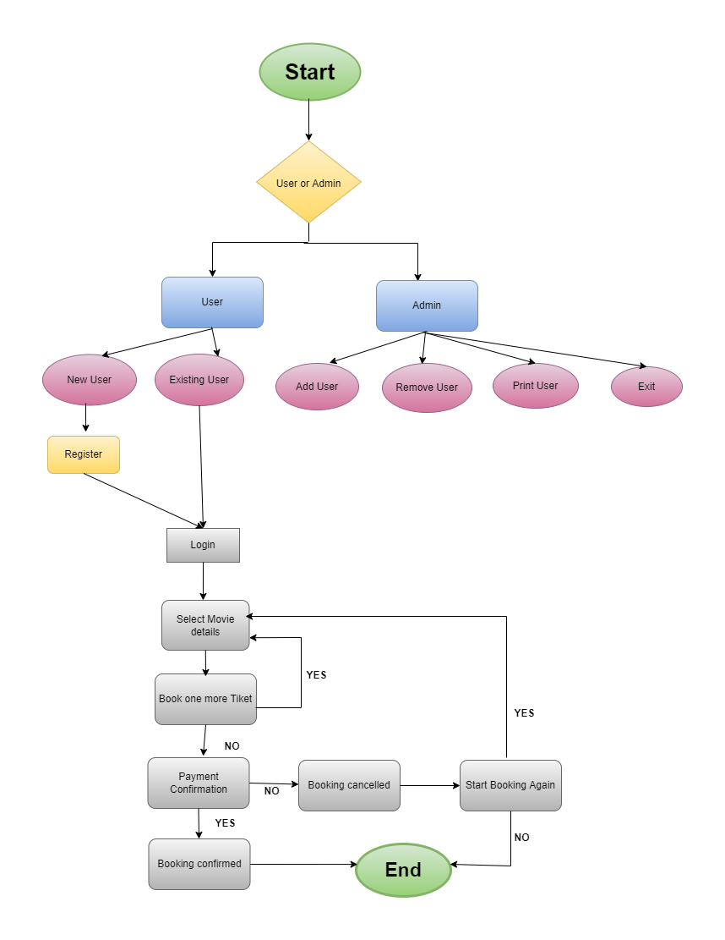

**GitHub Link:**

Under the repository TEST_ABC, the file named MovieTicketSimulator is the project file.

<https://github.com/PradeepaSaravanan/TEST_ABC.git>